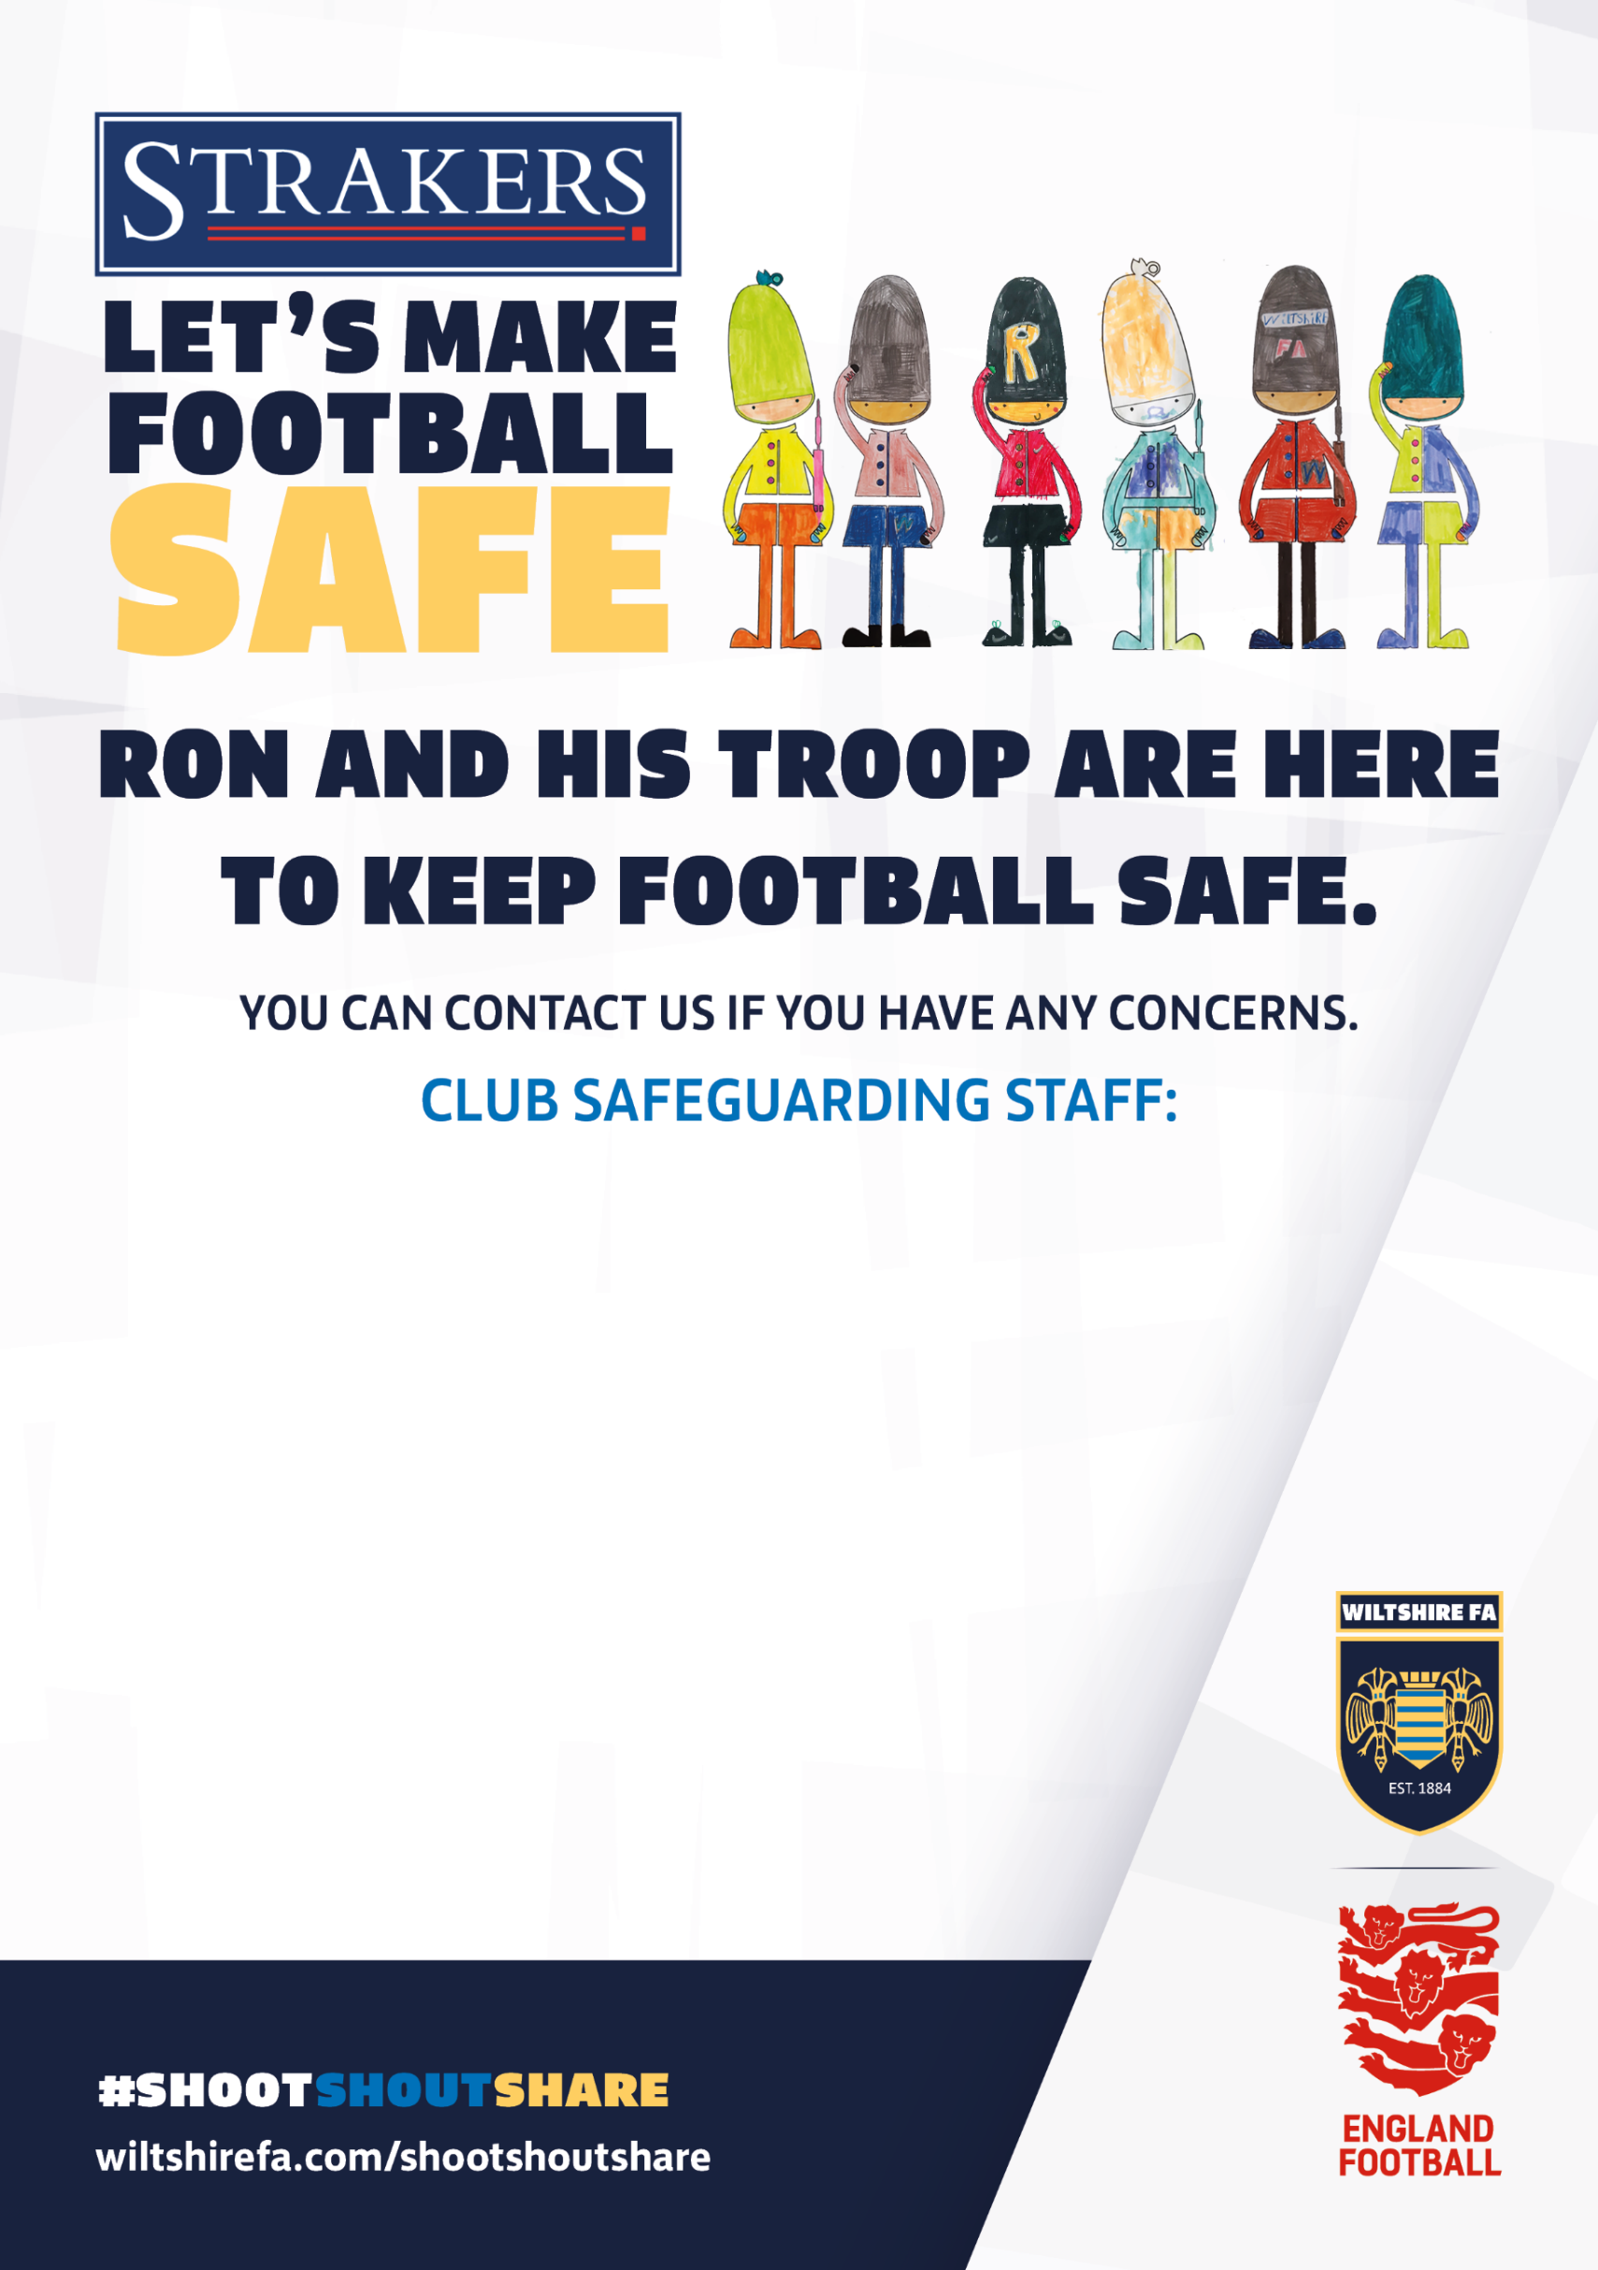

CLUB WELFARE OFFICER
Andy Mullen
CONTACT DETAILS
07850 450319 st.andrewsfdc@gmail.com
WE BELIEVE EVERYONE SHOULD ENJOY THE POSITIVE EFFECTS OF FOOTBALL AND FEEL CONFIDENT AND SAFE TO SHARE ANY CONCERNS.
St. Andrews F.C. IS A PLACE WHERE YOU CAN SHOOT FOR YOUR GOALS BUT IS ALSO A PLACE WHERE YOU CAN SHARE ANY WORRIES OR CONCERNS.

